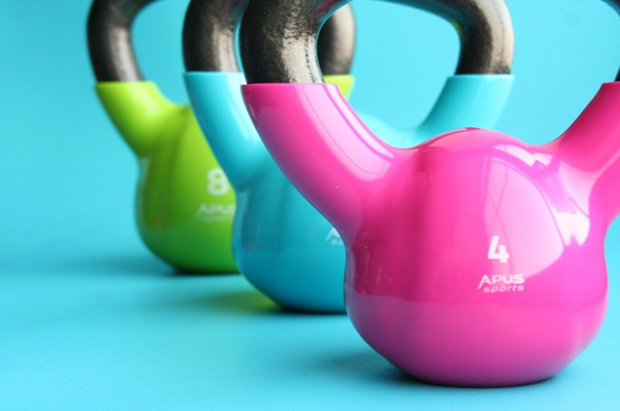

L I F T ( L I F E L O N G I M P R O V E M E N T S T H R O U G H F I T N E SS T O G E T H E R )

LIFT IS FOR AGING ADULTS WHO WANT TO EVOLVE INTO A MORE HEALTHY, ACTIVE LIFESTYLE

LIFT is an in-person, group-based strength training program that lasts 8 weeks. Participants meet 2x/ week for
1-hour sessions. The classes help improve your strength and mobility, learn healthy food options, and most importantly help form a community.

MAKING TIME FOR EXERCISE CAN CHANGE YOUR LIFE
I N T E R E S T E D I N J O I N I N G ?

F I N D O U T M O R E T O D A Y. A T
p a r c i l a b . o r g / l i f t p a r t i c i p a n t s
O R
C O N T A C T Y O U R L O C A L H E A L T H E D U C A T O R T O D A Y !

Name:
Phone:
Email:

