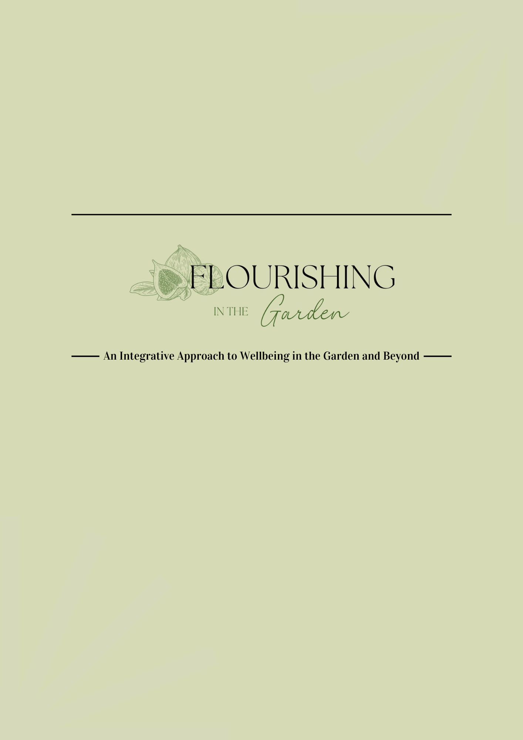
Table of Contents

Supplemental Materials
Facilitator Planning
Sample Schedule
Community Donations/Asks
Program Inspiration and Organization Infographics
Newsletters (Participant)
Meditation and Breath Scripts (Facilitator)
Nutrition Aspects and Recipes (Participant)
Weekly Garden Lessons
Weekly Journal (Participant)
Weekly Session Journal Prompts (Participant)
Extra Activities (Participant)
Values Assessment Definitions (Facilitator)
Pre/Post Assessments (Participant)

Flourishing in the Garden
Facilitator Planning

Who will you be working with? What community partners do you plan to have?

What is the group/organization's mission or purpose?

Do you have support from additional staff/volunteers to lead the program?

What are the guidelines/rules in place for participants? (If none are in place by the host, what will you offer for group guidelines?)

What resources do you plan to leave with your community partners/host for better understanding of the program?

How many days per week do you plan to offer FIG?

How long will your sessions be?

How many participants will you have?

Is there a garden space or raised beds on site? If so, are there tools, access to water, staff to support the maintenance of the space?

What is your program budget?

Do you plan to gather donations? (Walmart, Lowe’s, local gardening stores/nurseries tend to offer support to community initiatives when it comes to seeds, plants, and materials) *See community donations ask doc*

What activities do you plan to do each week with the group?

What materials are needed to complete these activities?

Flourishing in the Garden
Sample Schedule

Time | Focus Area | Notes

Flourishing in the Garden
Community Donations Asks

- Spend time prospecting/gathering information on each company's specific corporate giving initiatives. They all have slightly different approaches, guidelines, and preferences in how they want to be approached. This will help you prioritize your asks and figure out which company is a good fit for each type of ask.

- Call each store and ask who is the local contact for community giving, store product donations, and volunteering.

- From there, we can better judge how to formulate the ask. In some cases, the contact may request a formal letter from you with specific information. In general, I would steer clear of a generic solicitation letter.

For garden specific asks, Lowes and Walmart are great about donating supplies like soil, hand tools, pots, seeds, and plants. If you can catch Lowes/Walmart at the end of the season, they will typically donate their excess seeds because they cannot be sent back to the distributor.

When crafting your ask, be sure to include who you are, your position, and the organization you work for. Share who your community partners are, their mission, as well as the participants you plan to work with. Explain what program you are offering, and the intentions, goals, and outcomes that you are working towards.

Depending on the process for each organization, you can go in person, speak to the manager, and hand them the ask letter so they can put a name to a face. This not only makes the situation more personal but also shows who you are and your dedication to community.

Program Inspiration and Organization Infographics
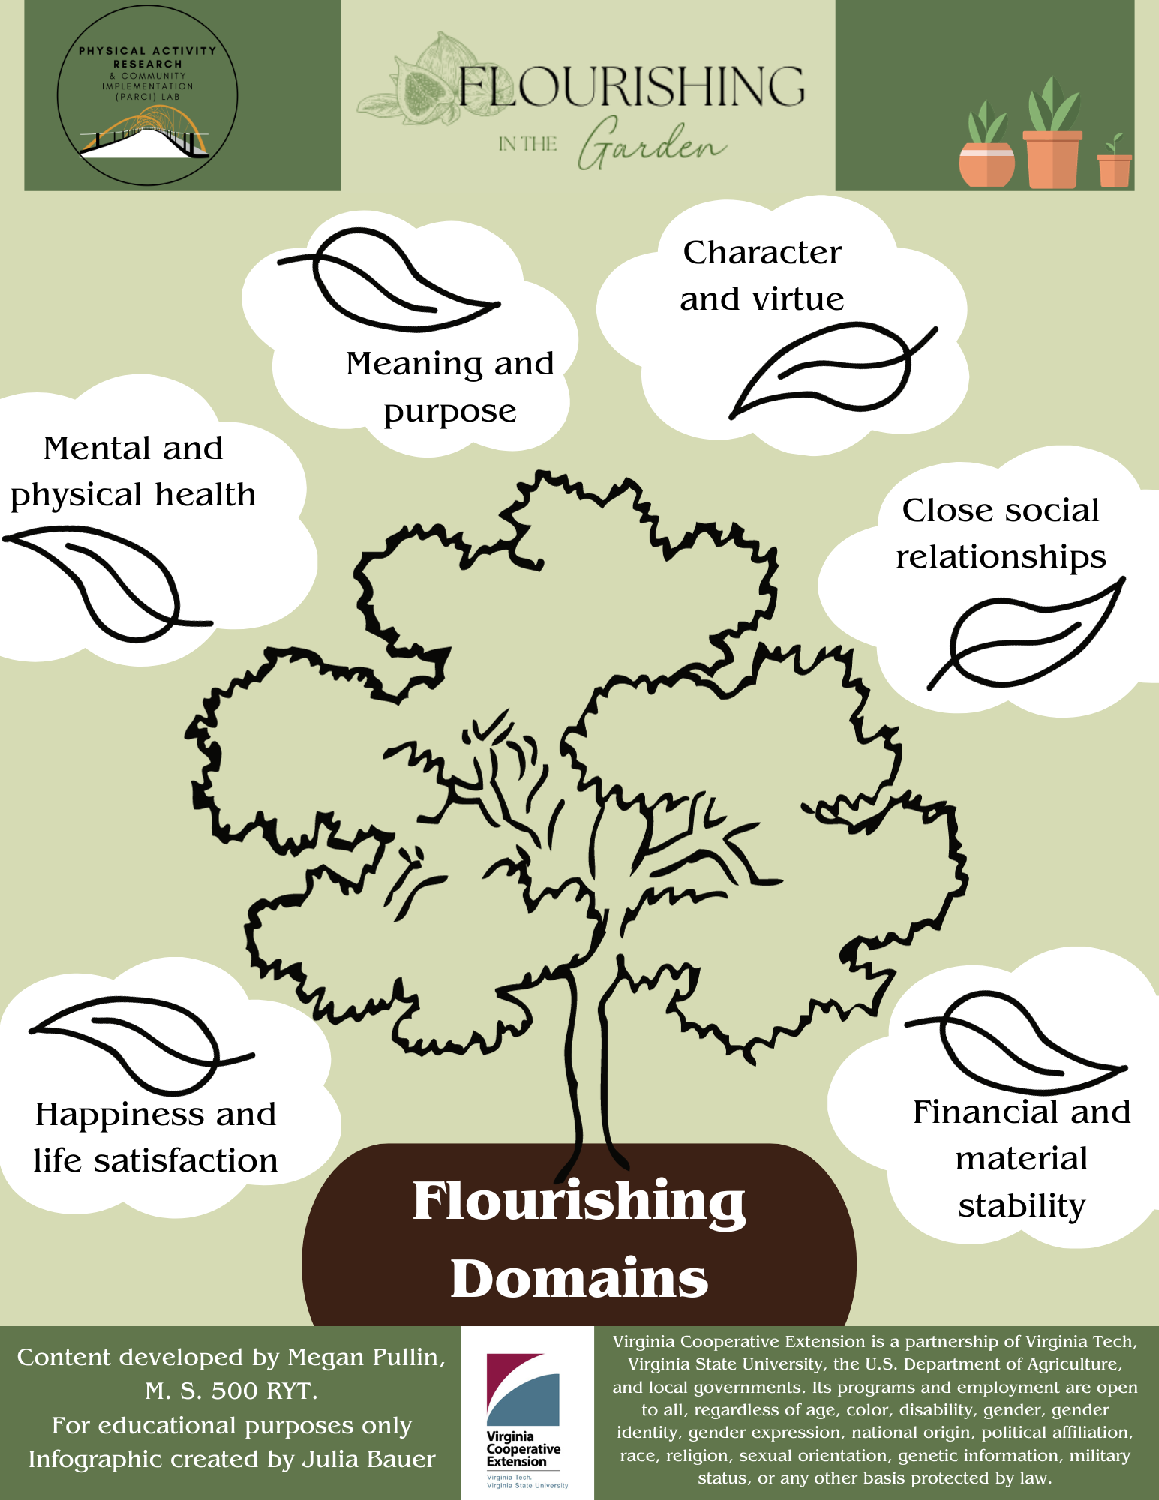
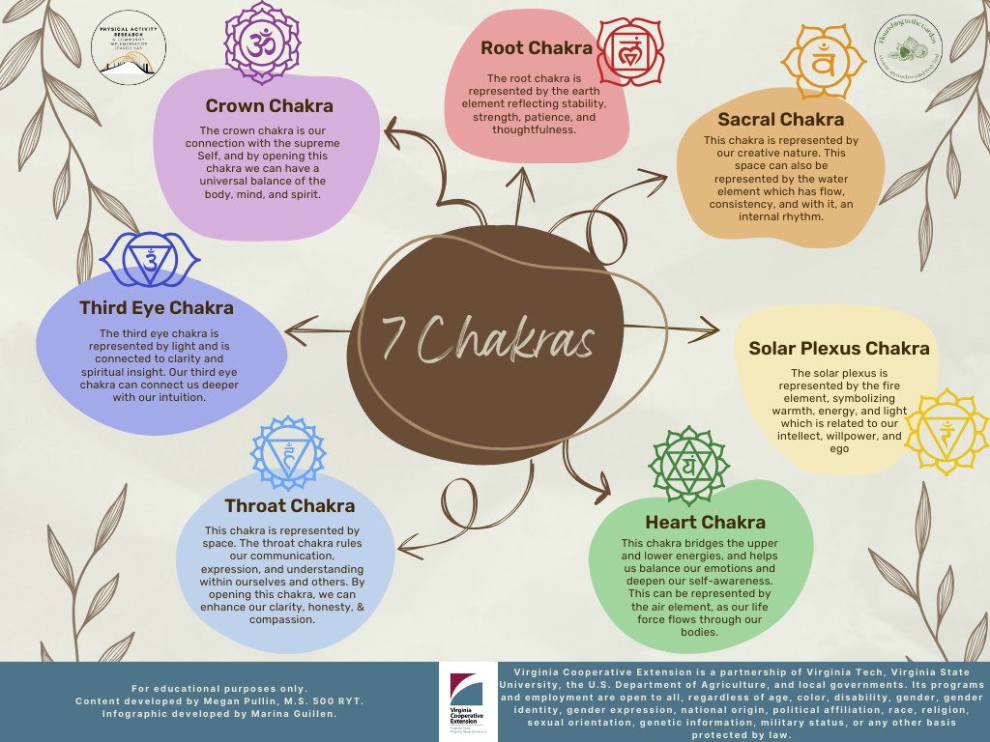
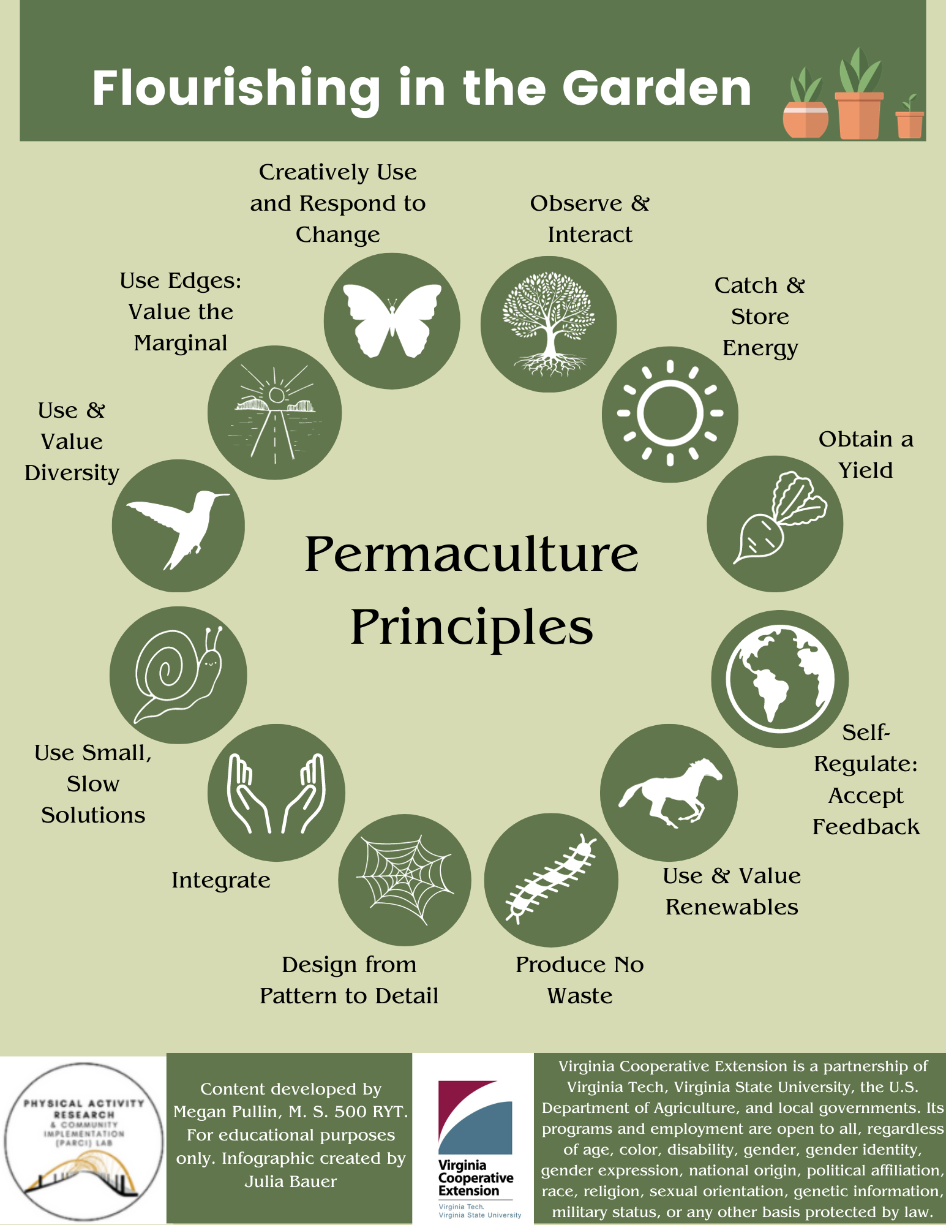

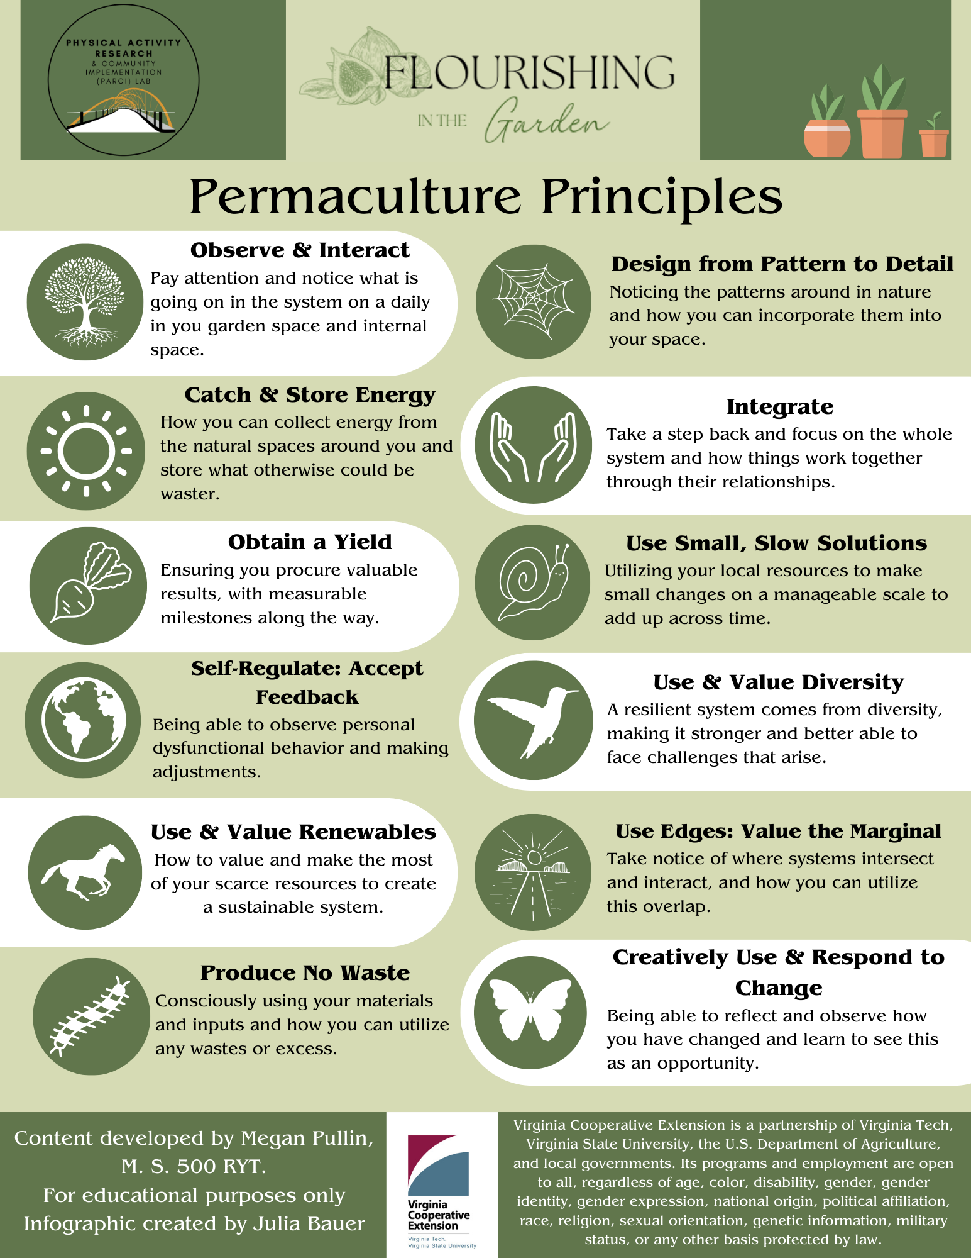

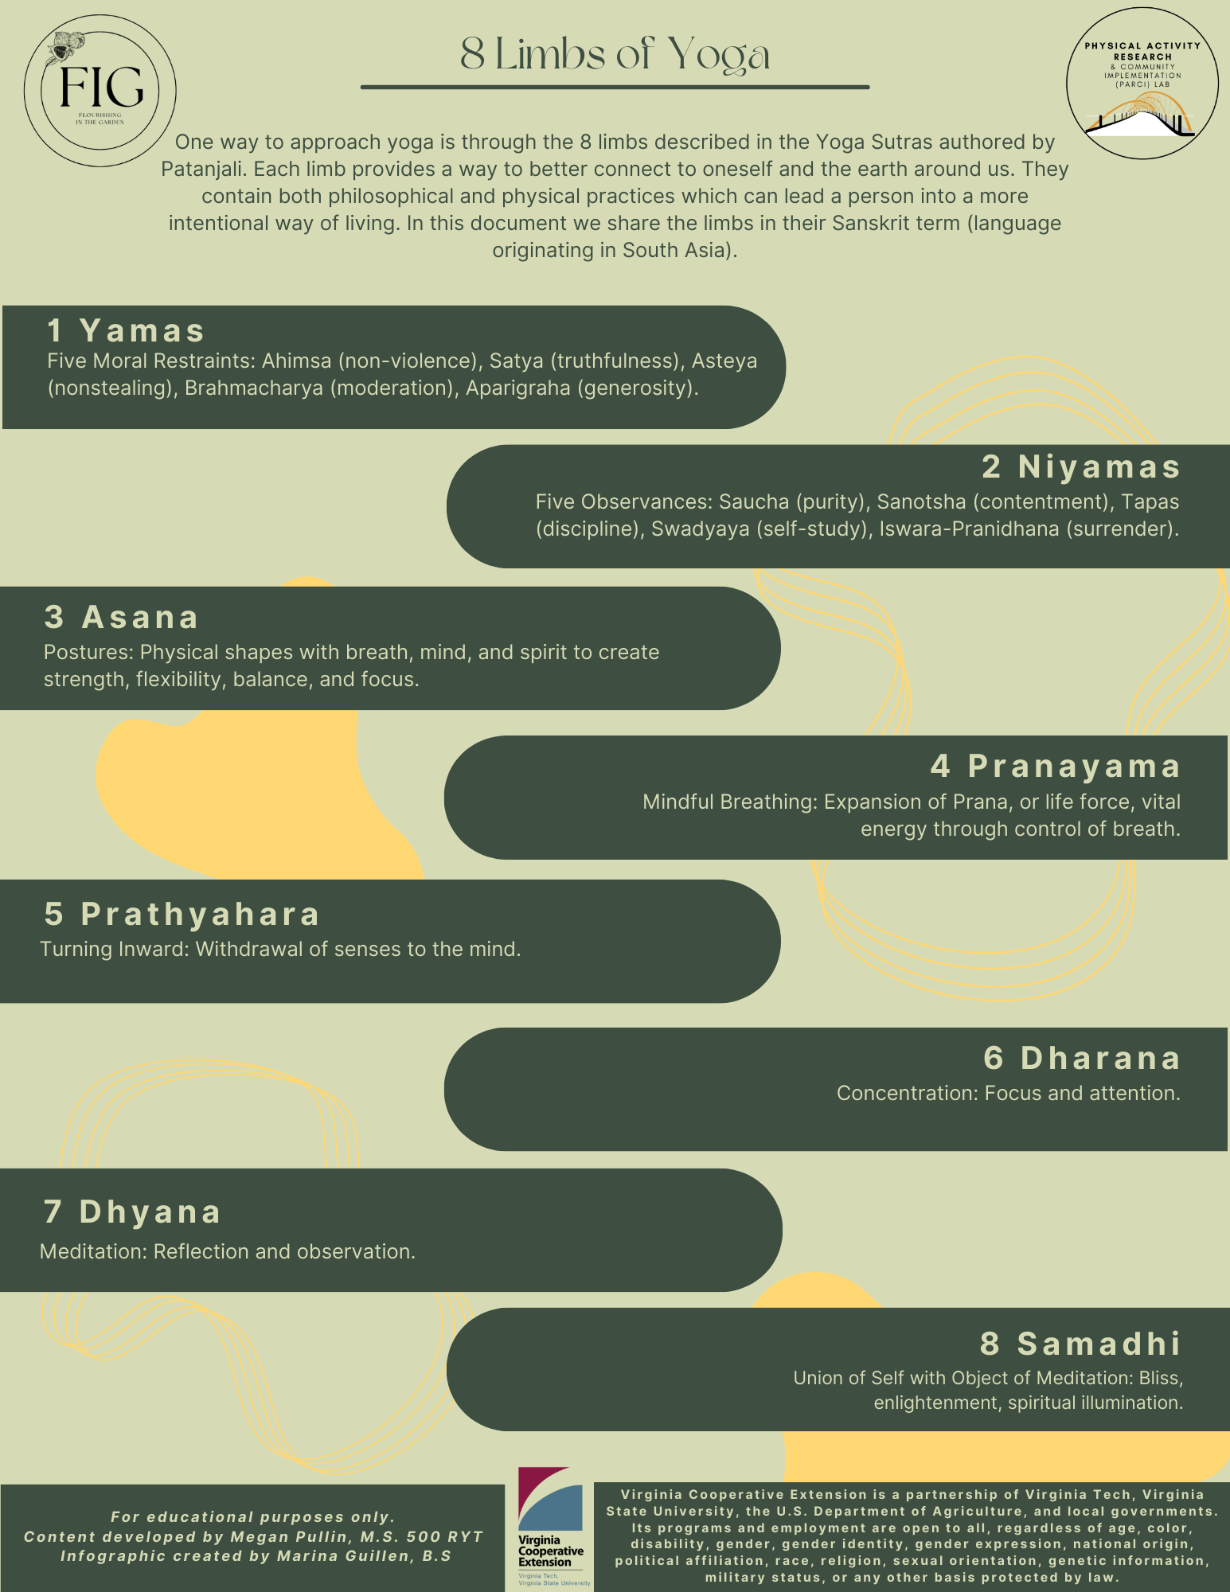

Newsletters
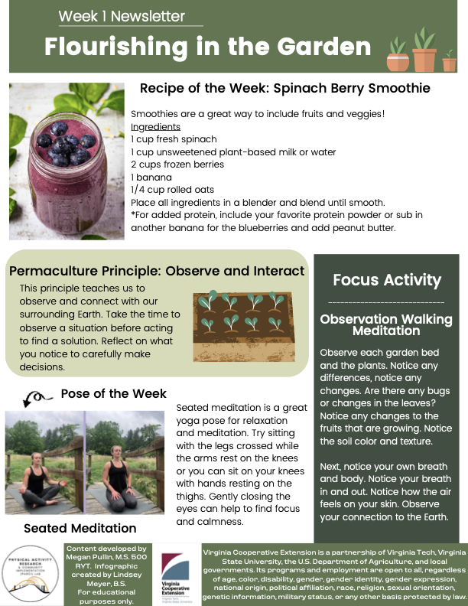

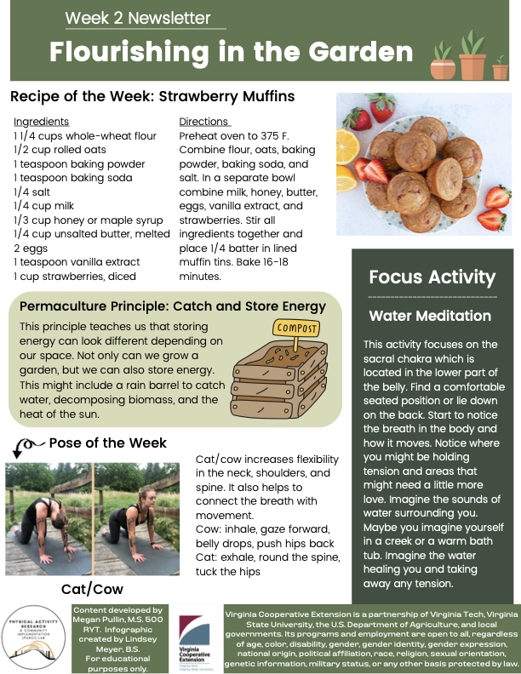

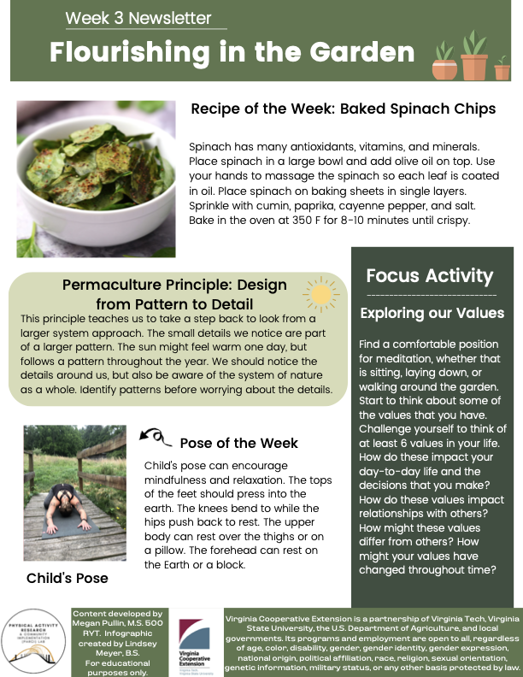

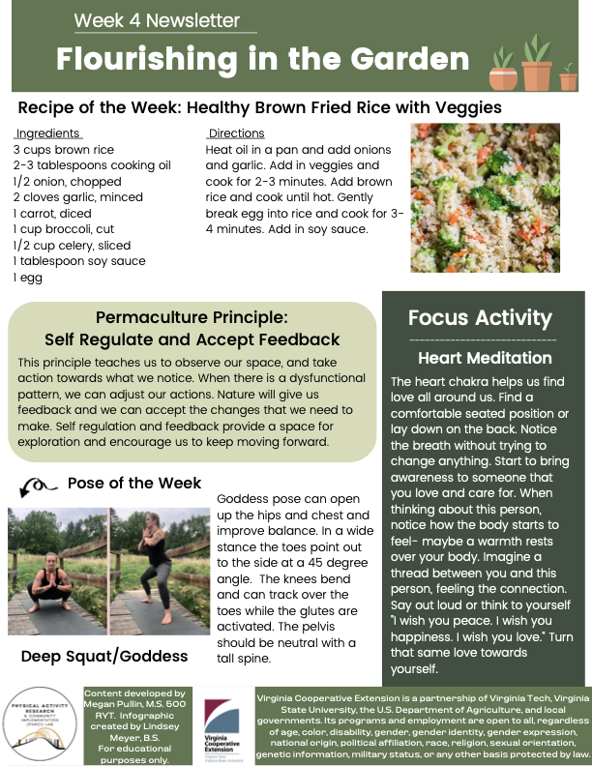

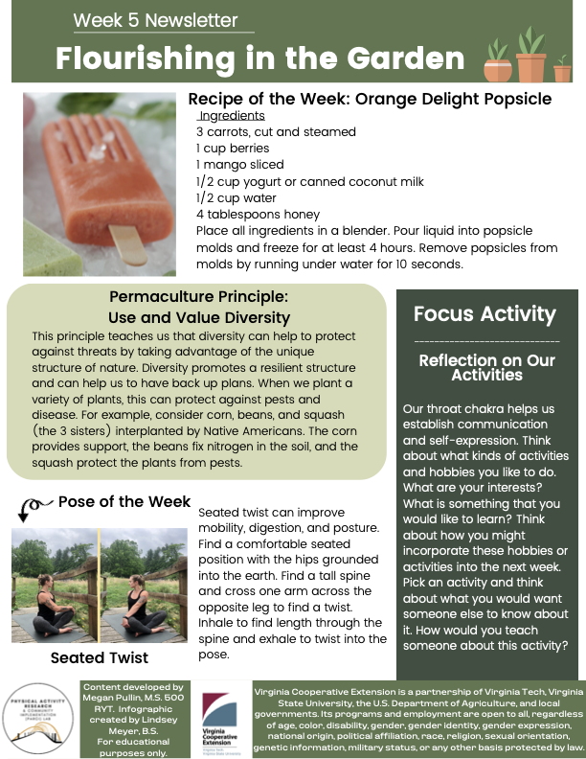

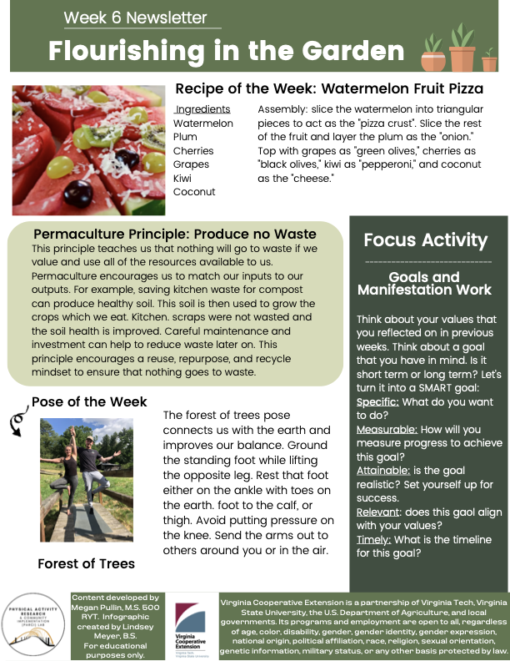

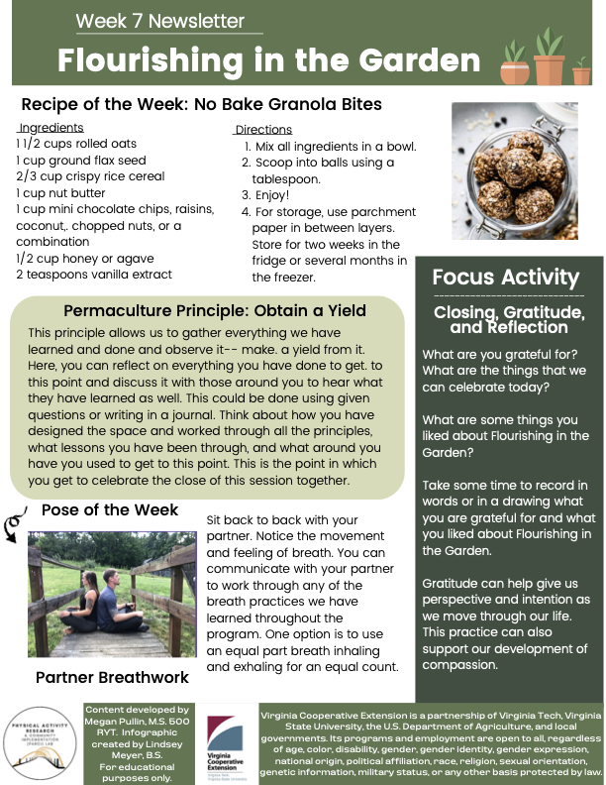

Meditation // Breath Scripts

Basic Body Scan
Week 1 // Lesson 1

Welcome to a short body scan.

You can start by finding a comfortable position so maybe that is seated with your legs crossed, maybe seated in a chair. Maybe you find a space on the ground that you can recline back and lay down on your back. But from here, take whatever you need, any position, and then allow yourself to start to settle into this position and if it feels comfortable, you can close your eyes and if not, that's okay. Just wherever you are, starting to settle into your space.

We will start first just by noticing the breath. Start to notice how the breath wants to move through the body. Maybe noticing the pace of your breath or the rhythm of your breath. Noticing the temperature of your breath. Maybe noticing how deep your breath goes into your belly, noticing the spaces that it's moving.

And again, this is all just feedback. So we're just noticing, no need to judge or quantify, just taking in information.

And then from here we'll start to work through the body scan. So we'll start at the feet just noticing any sensation in the feet

We will move up through the ankles and the calves just noticing the space.

We will move through the knees and the upper part of the leg, the hamstrings and the quads just noticing any sensation here.

Now move up to the hips and just notice the space. The space that's connected to the earth: the backside of the hips, the front of the hips, sides of the hips.

Then we'll move up through the belly and the back. Noticing again that full space, so the front of the belly, the sides of the ribs, lower back, arching your back.

Then we'll move up and notice any sensation in the heart space. So again, noticing that full space here from the back, the shoulders, the upper parts of the side ribs, the chest, maybe noticing the collarbones and just noticing any sensation in the space.

We'll move up to the top so the shoulders in the upper arms. Noticing the triceps, biceps and noticing the elbows noticing any sensation here.

Now move to the lower parts of the arm, the forearm, the wrists and notice the hands, the back of the hand, palm of the hand, the fingers and just noticing any sensation here.

Then we'll work our way back up the arm past the elbow, the upper arm to the shoulder and we'll find ourselves at the neck. Noticing any sensation here and again the full space so the throat the sides of the neck, the back of the neck.

Then maybe starting to move up into the heads and noticing the chin and jawline. Noticing the back of the head, the face the ears on the sides of the head and then noticing the crown, that space right at the top of the head.

Then we'll take a step back, from noticing one part at a time and you can even imagine yourself floating above your body, looking down at yourself, and allow your awareness to grow from the crown of the head to the rest of your body.

Still allowing that focus area to grow.

Now notice the totality of your own body in space here and just allow yourself to surrender to the earth just for a few moments, soaking in this awareness.

If you notice the group moving or fidgeting this can be a helpful technique (If at any time you need support to stay in this meditative space, you can always start to tap your thumb and your finger. Your thumb and your middle finger, thumb and your ring finger, and thumb and pinky finger. So just kind of tapping the fingers can help to bring your awareness back to the body if it goes somewhere else.)

Just taking a couple more breaths here to be in this space.

And then when you're ready, you can start to bring awareness again back into the body. Maybe by wiggling the toes and the fingers. Take a nice deep breath. Maybe take a long stretch along the earth and then when you're ready, you can hug knees into your chest and roll over to one side.

Now take a moment here on your side to breathe and think of one thing that you're grateful for.

Then with that gratitude press up to a seated position, you can keep your eyes closed or you can keep your gaze down at the ground.

We will end our practice here with one sound of om. So you can join in and make the sound, you can hum along, whatever you would like.

We will inhale to prepare.
~OMMMM~

Thank you for sharing this body scan practice with me.

Water Meditation
Week 2 // Lesson 2

Hello, and welcome to week two of flourishing in the garden. This week focuses on the sacral chakra which is located right in the lower parts of the belly.

This space is related to the water element but also to our creativity and to our flow in life. That space that we can just tap into and we don't really have to think that much. We can just go with it. We can do and act from a space of passion and integrity.

We'll start a short water meditation so you can find a comfortable seated position if you'd like, you can find a comfortable reclined position if you'd like to lie down on your back. Or you can sit in a chair.

Wherever you are, start to notice the breath in the body.

Notice how the breath is moving.

And then we'll do a quick body scan. Just noticing any space in the body that might hold tension.

Any space in the body that might be tight or any space in the body that just needs a little bit more love today.

So as you start to notice those areas or those spaces, if you would like you can rest the hands on those spaces just to bring your awareness there or you can just energetically think of those spaces and bring your attention there.

From here, no matter the story, no matter what happens, no matter anything that has to do with that space, we're noticing maybe the tension and the feelings and we'll stick with that.

We'll notice the feelings associated, maybe noticing the temperature, the quality of that space.

Now, maybe you imagine yourself in a creek, maybe you imagine yourself in a warm tub.

Then we'll start to allow the water and sounds of the water to wash over us imagining water just rushing over that space.

Start to think about what kind of water and what temperature water you would like to have running over that space.

What would be healing for you?

So is that Cold Creek water or is it a warm hot spring?
Let’s imagine the water just rushing over that space to wash away any of that tension or any of that energy, any of that sensation to just wash it away.

Now rivers are continuous and they continue to flow regardless of the things happening around them.

The levels might change. The seasons might change.

The geology might change, the rocks might shift, and over time the rocks might become worn down.

You might have trees growing into the river, you might have other plants and vegetation that rose up through the rocks in the summertime, low water levels.

But just knowing that the water that flows is consistent. That lifeforce keeps coming in. So just imagining that water to rush over the space that you need it.

Just continuing to feel that healing touch of the water to wash away any sensation to wash away any tension, anything that you don't need from your body, anything that you don't need from your mind. Just continuously allowing the sound of the water and imagining visualizing the water splashing over you washing it away.

So slowly start to draw our attention back inward to the body, slowly starting to draw it back
Maybe finding a little bit of movement here.

Maybe wiggling through the fingers and the toes.

Maybe gently taking a long stretch along the earth.

And then we'll hug the knees into the chest squeeze the knees in giving yourself a big hug

And then we'll roll over to one side.

So as you roll over, take a moment here again if you would like to hug the knees in allowing yourself to take a break here just resting to take a breath

and then think of one thing that you love about yourself

with that in mind we'll start to rise to seated

slowly then we start to tuck the chin

OPTIONAL
and we'll end this meditation with one sound of OM

So the OM represents a vibration or a sound that connects all beings together. So you can hum along if you'd like make the sound but will inhale to prepare

Thank you all for sharing this water meditation with me until I see you guys again, Namaste:)

Progressive Relaxation
Week 3 // Lesson 3

Hello and welcome to a progressive muscle relaxation.

Find yourself a comfortable resting position, either lying down where you can recline on the back or you can find a comfortable seated position.

We'll start to work through this progressive muscle relaxation. And the intention is that we will add in muscle contraction intention and hold. And the thought is that if there was tension in that space before, that as we add in more tension, we're engaging those muscles that when we release, all of the tension is released with it.

We'll start at the feet and work our way up the body.

You can start by engaging all the muscles of the feet. So squeezing the toes for three, two, and one, release. Let it go.

We'll move up to the leg. So we'll focus on the lower legs, the calves, the shins, and ankles. The knees, the quads and the hamstrings. Just squeezing the legs here for three, two, and one, release. Let it go.

And then we'll move up to the central part of the body. So we'll focus on the glutes and the hips, the lower back and the core. Engaging those muscles squeezing here for three, two, and one, release. Let it go.

And then we'll move up to the chest and the shoulders. So squeezing here, engaging the shoulders, maybe drawing the shoulder blades together, squeezing through the chest, for three, two, and one, release. Let it go.

Now we'll move out through the arms and the hands. So we'll squeeze the hands into fists or engage through the forearms, the triceps and the biceps. And we'll squeeze here for three, two, and one, release. Let it go.

Now I'll move up to the tops of the shoulders and the neck. So squeezing here and engaging those muscles for three, two, and one, release. Let it go.

And then we'll move up to the head. So engaging all the muscles in the face, the ears, squeezing here for three, two, and one, release. Let it go.

And so now we'll engage all the muscles here. From the feet up the legs, the core, the hips, the glutes, engaging the hands, the arms, the face, squeezing all the muscles in the body here for three, two and one, release. Let it go.

So just allowing your body to relax, to let go of tension and to just melt into the earth here.

We'll take just a little bit of space to soak in this progressive muscle relaxation.

~

And then when you're ready, you can start to come back into the body, maybe wiggling the toes and the fingers.

Maybe taking a nice long stretch along the earth.

And then when you're ready, you can hug the knees into your chest.

Wrapping yourself up in a big hug and then you can roll over to one side. Take a breath and think of one thing that you're grateful for

And then when you're ready, you can come up to a comfortable seated position of your choice.

Slowly integrating back into the world so maybe blinking the eyes a couple times you can keep the gaze low.

Thank you for working through this progressive muscle relaxation.

Heart Meditation
Week 4 // Lesson 4

Hello and welcome to week four of flourishing in the garden. This week is focused on the heart chakra and also related to the air element. So here we will come into a loving kindness meditation or heart meditation.

To start you can find a comfortable seated position or you can also lay down on your back. But just take anything that you need here, any kind of support whether that be props or intentions, and feel free at any time to move and adjust so that you can be comfortable in the space.

So as you make your way to that position, we'll just start to notice the breath so you can start to breathe in and out without trying to change anything

just noticing the quality of your breath, noticing where the breath wants to move in the body

then maybe starting to expand the breath into the belly. Noticing that full expansion of the ribs and then as you exhale, the ribs come back together.

Just noticing that constant flow and movement

and then start to bring your awareness to someone that you love. Someone that you deeply care about. So this can be family, it can be a friend, it can be a pet

Just start to bring that being into your mind

and then with that being in your mind start to notice how the body is feeling.

So maybe the heart space is tingly.

Maybe there is sensation there.

Maybe there's a warmth that rests over your body.

Maybe you're thinking of a distinct memory and you have a smile that comes to your face which is keeping that being in your mind and allowing that love to expand and radiate from you

Now we'll start to direct energy to that being.

So maybe imagining a thread between you and this person. And it doesn't matter how far they are away from you. But just feeling that connection to them and sending them that love and maybe feeling that love come back to you

feeling this constant flow between the two of you

maybe noticing other sensations or emotions that come up whether that be gratitude, light compassion

and then with that energy you can say either out loud or you can think it to yourself.

But you can repeat

“I wish you peace. I wish you happiness. I wish you love.”
“I wish you peace. I wish you happiness. I wish you love.”
“I wish you peace. I wish you happiness. I wish you love.”

so you can continue that or you can let all of it go and just soak in that love and connection

so now with that same love and connection that we can share with another Being. We're going to start to take that feeling and we're going to turn it inwards to ourselves.

So sometimes it can be a little bit easier to send that love to another being, to someone else outside of ourselves.

You can imagine we're holding up a mirror right in front of our face. And we're going to turn that same love and compassion right back to ourselves.

Because we deserve that love too.

An option is to let your hands rest on your heart.

Now starting to again turn that love in and as you look in the mirror, repeat

“I wish you peace. I wish you happiness. I wish you love.”
“I wish you peace. I wish you happiness. I wish you love.”
“I wish you peace. I wish you happiness. I wish you love.”

so you can continue that or you can let all of it go and just soak in that love and connection

So with that love being reflected back to yourself we’ll start to expand that feeling over the entire body.

Allowing the body to just rest here.

feeling the sensation of that loving kindness, this beautiful pathway that starts within us and that transcends out into the world.

Love and abundance from the world being able to be transferred back down the path to us

noticing this free flowing of energy of abundance and love

just knowing that this work, this intentionality, this love is available to you at any time. And that you deserve it.

So with all that abundance here, We'll start to bring our awareness back into the body.

Maybe taking a nice long stretch along the earth

Rolling through the wrists and ankles

and we'll hug the knees into the chest and roll over onto your right side

then from here, take a moment to breath

feel free to keep the eyes closed or the gaze softened

But just take a breath here and think of one thing that you love about yourself

When you're ready, you can come to a comfortable seated position of your choice

I thank you all so much for sharing this practice with me today. And until I see you guys again namaste.

Lion’s & Bee Breath
Week 5 // Lesson 5

Facilitator Tip (Do not read outloud)
Usually, especially when teaching this to youth this produces some giggles and some laughs, which is great. That's kind of what we want. We want to just really come back into our bodies here.

And so that's what this breath can help with. It is also an active and invigorating breath. It can also be helpful to release any kind of energy so this tool can be used throughout your lessons.

We can just pop right into Lion's Breath if you're noticing kids are distracted or maybe not able to focus. We can use this breath as a tool.

Because this breath is a little bit more active and invigorating, I usually like to do like three to five rounds and just kind of gauge how the group is doing. And so with this, just encourage again, on our inhale, you're starting to maybe cue lifting through the spine, opening through the heart on that inhale, and then exhaling, sticking out the tongue and letting it go.

Start Reading to Cue Breath
For this week we are focused on the throat chakra which is also associated with space or the ether element. And in this space will really tap into our vocalization and expression in the space.

Our two practices for the week are going to be Lion’s breath and then bee breath. So both are different, activating breaths, but we can hold different intentions with each.

We'll start by finding our way into Lion’s breath. And so for this you can find either a comfortable seated position whether that's with legs crossed or you can find yourself seated in a chair. You can also sit with the knees bent and the shin bones resting on the ground.

From here, we'll start to draw the breath in.

And as you exhale, we'll stick the tongue out and again contract the throat using an audible exhale.

Inhale, and then exhale while sticking the tongue out.

Let's do a couple rounds of those. Well inhale. Exhale sticking the tongue out.

Inhale. Exhale, let it go.

One more big breath in. Exhale, let it go.

We will start to move into our second breath for today. This is called Bee Breath and it's a little bit more calming and relaxing.

If you notice in different animals or even babies, a lot of times to self soothe, they'll use that vocalization or humming sound. And so we're kind of recreating that in our breath here.

Inhale, and then exhale, we're gonna let it go and allow a humming sensation to come over this space.

Inhale and exhale humming here.

Once more, inhale and then let it go, humming it out.

*can cue a few rounds with a break in between to notice what is going on in the body and what sensation they are experiencing.

So that concludes out breath practice for the day.

Facilitator Information
With this breath, it usually automatically lengthens our exhale. So you don't necessarily need to cue that but it typically will happen naturally. A breath with a shorter inhale and longer exhale is going to be more calming in its nature. We're relaxing and it signifies to the body to activate the parasympathetic nervous system. We want to be present and notice what's going on in the space and in our participants, but this is typically what we might witness.

Lion's Breath, and Bee breath. Both are great options to incorporate some vocalization, release energy and tension in the body, as a tool for self regulation, and to bring the group back to the space.

Nutrition Aspects/Recipes

- Spinach Berry Smoothie
Ingredients:
- Spinach
- Berries
- Unsweetened Vanilla Almond Milk (or milk of choice)
- Banana
- Rolled oats
Directions:
Place all ingredients into a blender and blend until smooth.
- https://shaneandsimple.com/spinach-berry-smoothie/
- Strawberry Muffins
Ingredients:
- 1 ¼ cups whole wheat flour
- ½ cup rolled oats
- 1 tsp baking powder
- ½ tsp baking soda
- ¼ tsp salt
- 1 cup milk
- ⅓ cup maple syrup or honey
- ¼ cup unsalted butter (or avocado or coconut oil)
- 2 eggs lightly beaten
- 1 tsp pure vanilla extract
- 1 cup diced strawberries with stems removed
- 1 tbsp fresh lemon zest
Directions:
Preheat oven to 375ºF
Combine flour, oats, baking powder, baking soda, and salt.
In a separate bowl, combine milk, honey, butter, eggs, vanilla extract, and strawberries.
Stir all ingredients together and place ¼ batter in lined muffin tins.
Bake for 16-18 minutes.
- https://www.yummytoddlerfood.com/strawberry-muffins/
- Spinach Chips
Ingredients:
- 5 cups spinach leaves
- 2 tbsp olive oil
- 1 tsp ground cumin
- ¼ tsp paprika
- ⅛ tsp cayenne pepper
- ¼ tsp sea salt
Directions:
Place spinach in a large bowl and add olive oil on top and then use your hands to mix.
This ensures the spinach is properly coated in olive oil.
Place spinach on a baking sheet in single layers.
Sprinkle with seasonings.
Bake in the oven at 350ºF for 8-10 minutes until crispy.
- https://brooklynfarmgirl.com/baked-spinach-chips/
- Healthy Brown Fried Rice with Veggies
Ingredients:
- 3 cups brown rice
- 1-3 tbsp cooking oil
- ½ onion, chopped
- 2 garlic cloves, minced
- 1 carrot, diced
- 1 cup broccoli, cut
- ½ cup celery, sliced
- 1 tbsp soy sauce
- 1 egg
Directions:
Heat oil in a pan and add onions and garlic.
Add in other veggies and cook for 2-3 minutes
Add brown rice and cook until hot
Gently break egg into rice and cook for 3-4 minute
Add soy sauce
- https://bestrecipebox.com/fried-brown-rice-vegetables/
- Orange Delight Popsicle
Ingredients:
- 3 carrots, cut and steamed
- 1 cup berries
- 1 mango, sliced
- ½ cup yogurt or canned coconut milk
- ½ cup water
- 4 tbsp honey
Directions
Place all ingredients in a blender
Place liquid into popsicle molds and freeze for at least 4 hours
Remove popsicles from molds by running them under water for 10 seconds
- https://livesimply.me/fruit-veggie-popsicle-recipes/#recipe
- Watermelon Fruit Pizza
Ingredients:
- Watermelon
- Plum
- Cherries
- Grapes
- Kiwi
- Coconut
Directions:
Slice watermelon into triangular slices to act as the pizza crust
Slice all other fruit and layer the plum as the onion
Top with grapes as green olives, cherries as black olives, kiwi as pepperoni, and coconut as the cheese.
- http://hallecake.net/teenage-mutant-ninja-turtle-fruit-pizza/
- No Bake Granola Bites
Ingredients:
- 1 1/2 cups rolled oats
- 1 cup ground flax seed
- 2/3 cup crispy rice cereal
- 1 cup nut butter
- 1 cup mini chocolate chips, raisins, coconut,. chopped nuts, or a combination
- 1/2 cup honey or agave
- 2 teaspoons vanilla extract
Directions
Mix all ingredients in a bowl. Scoop into balls using a tablespoon. Enjoy! For storage,
use parchment paper in between layers. Store for two weeks in the fridge or several
months in the freezer.
-https://tastesbetterfromscratch.com/healthy-no-bake-granola-bites/

Weekly Garden Lessons
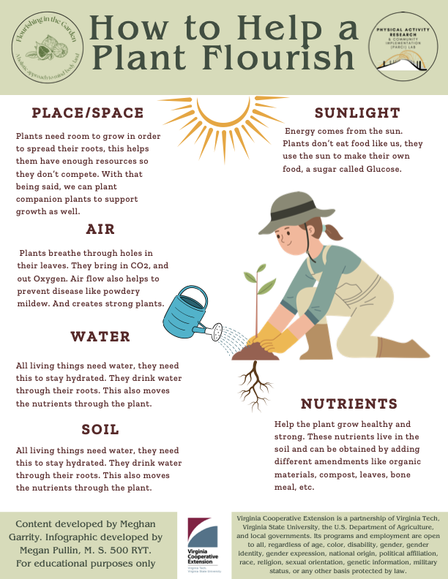

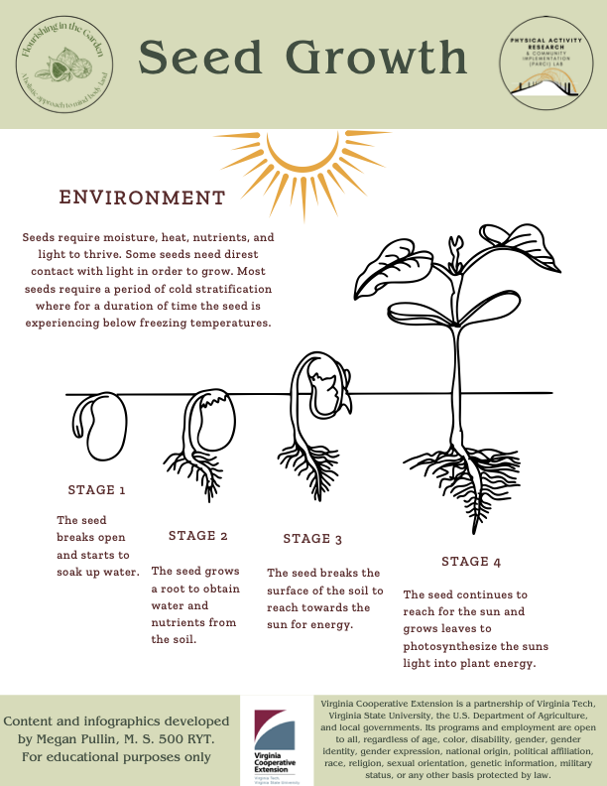

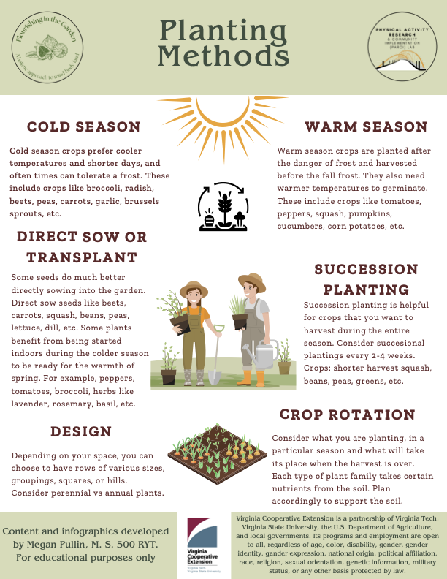

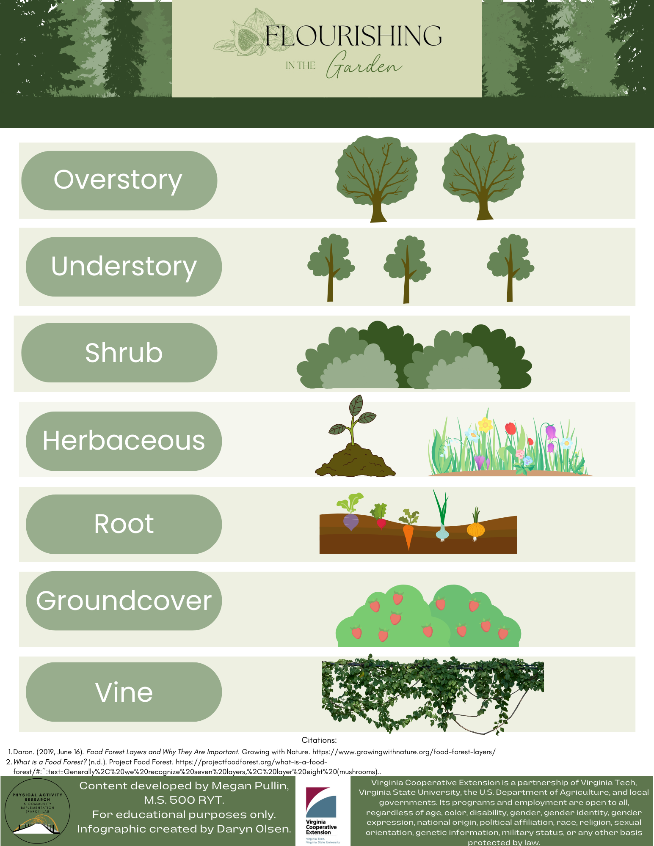
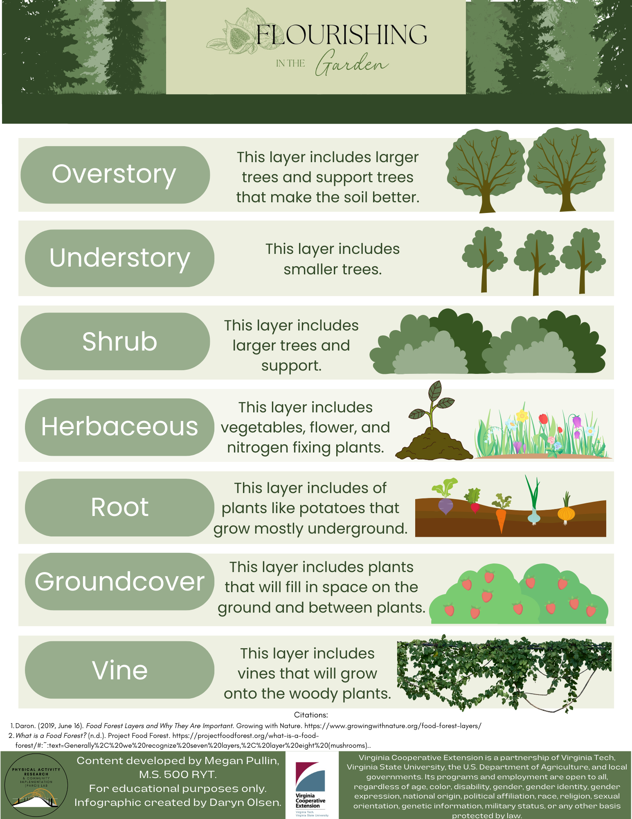

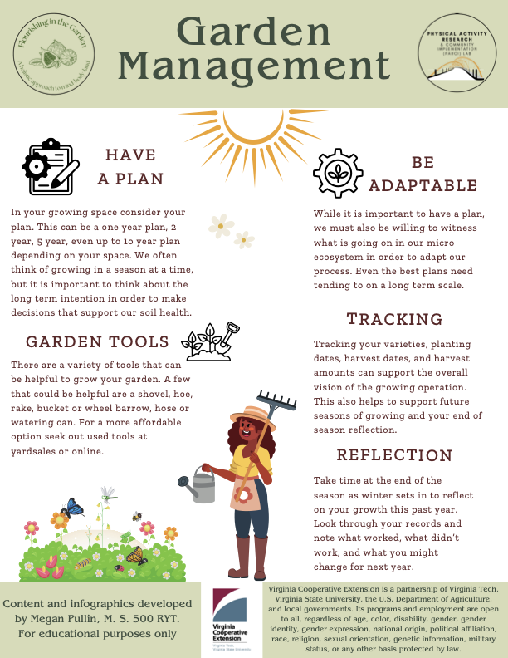

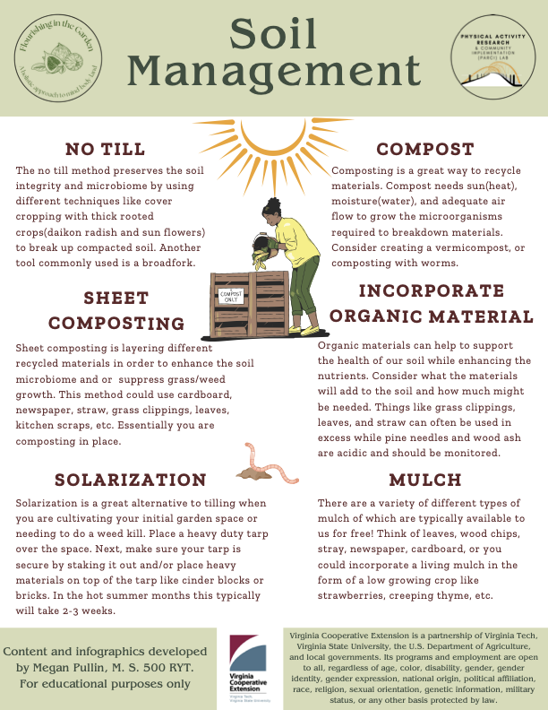

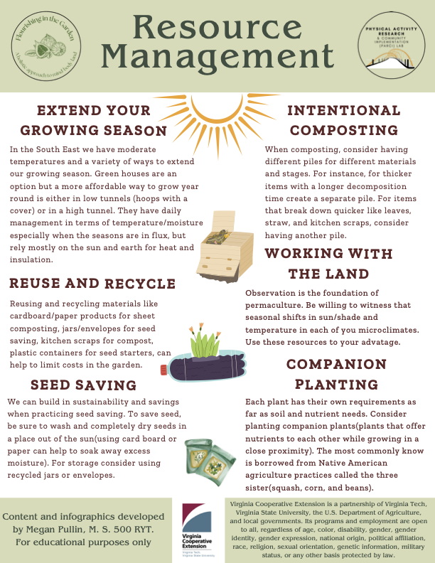

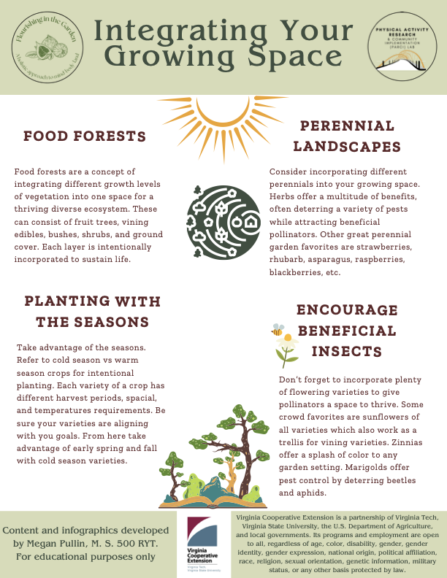

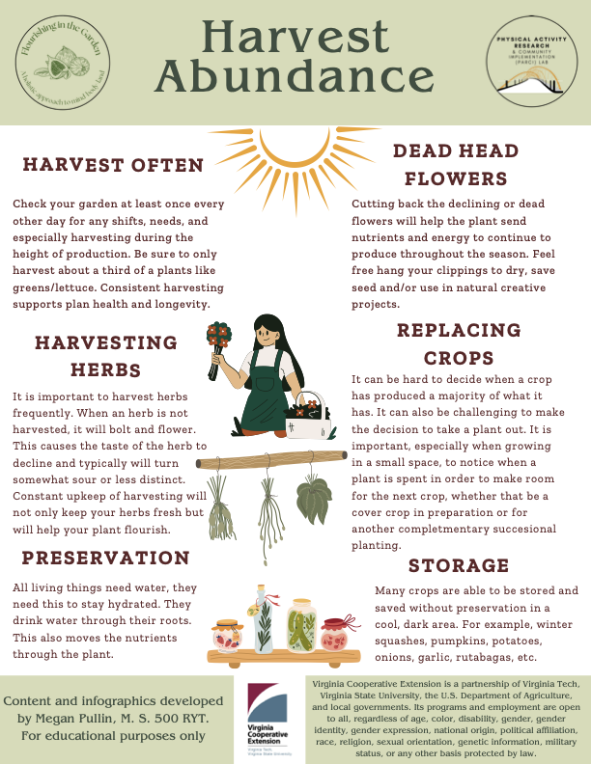

Weekly Journal

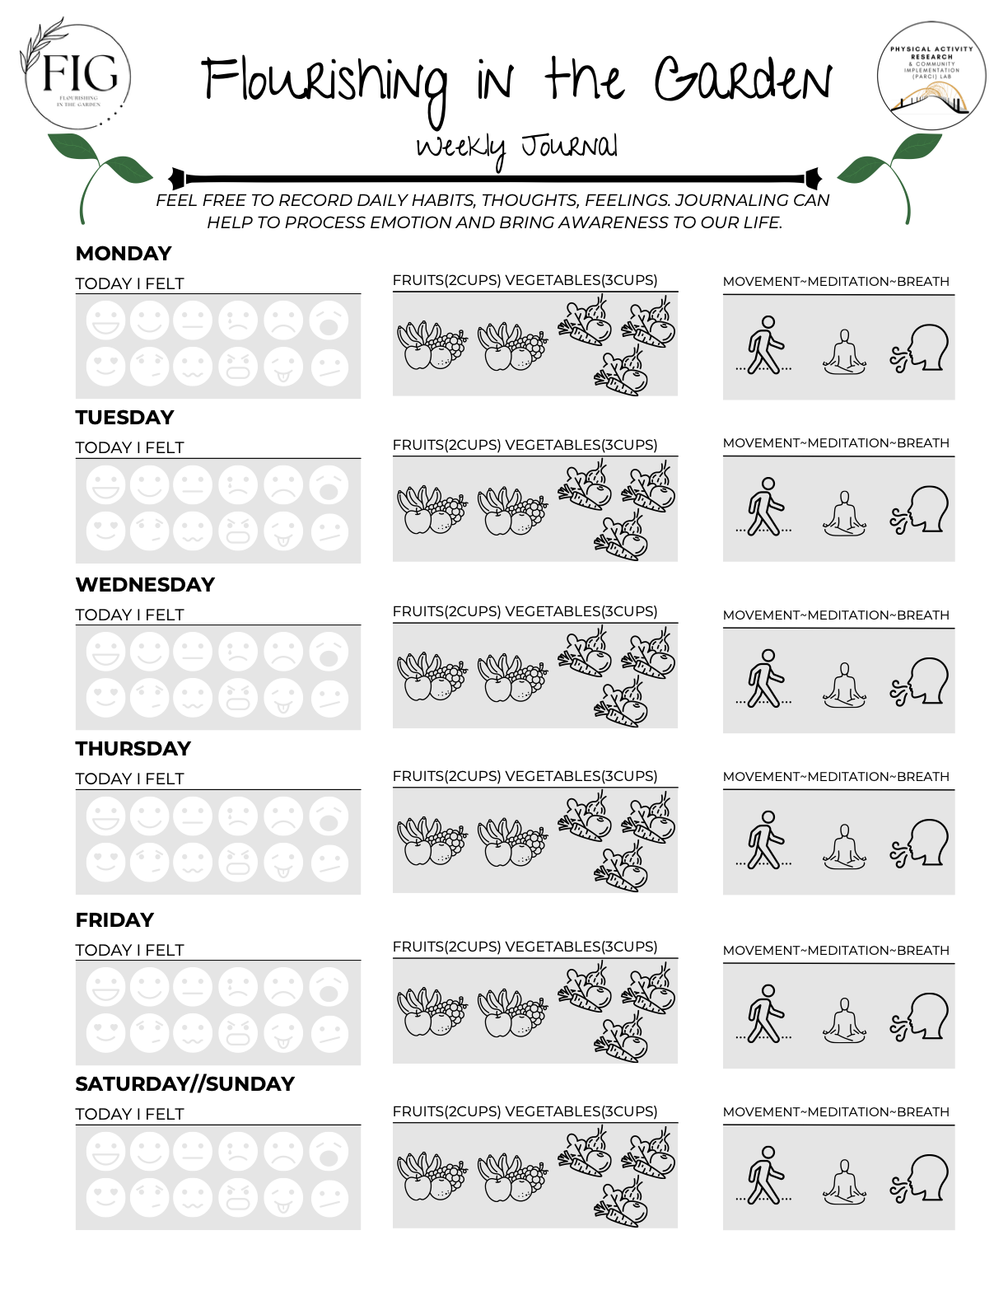

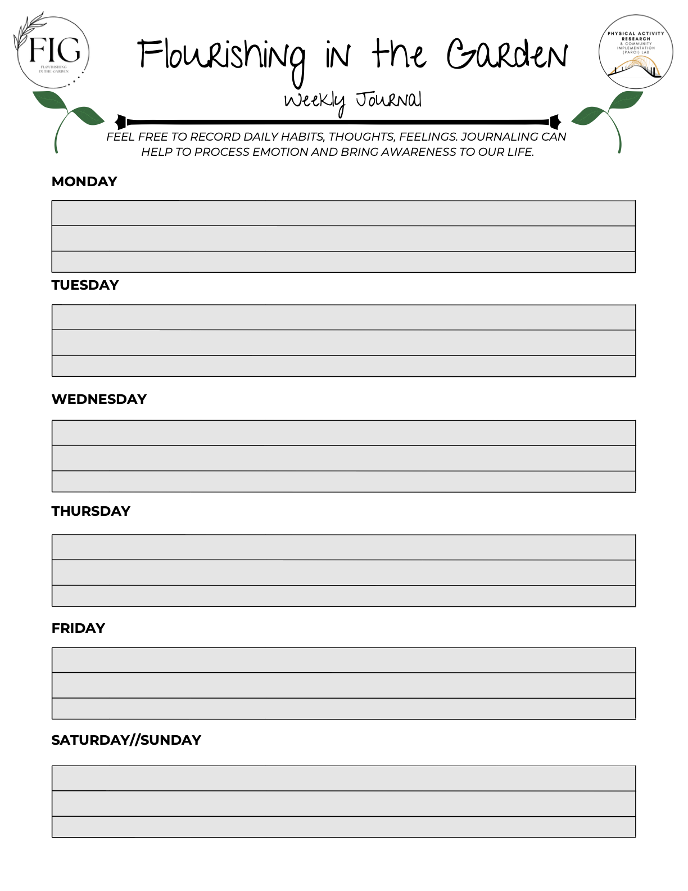
Journal Prompts
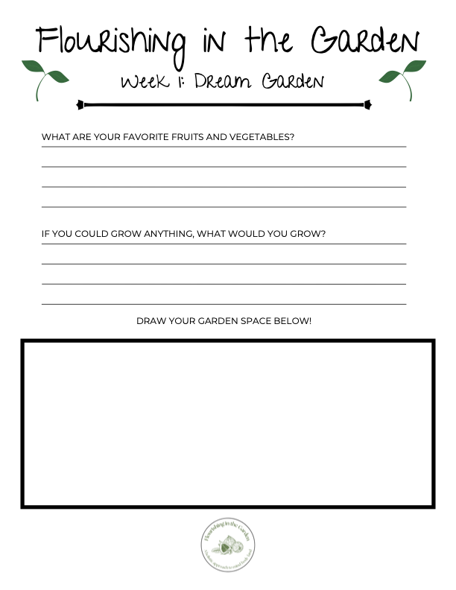
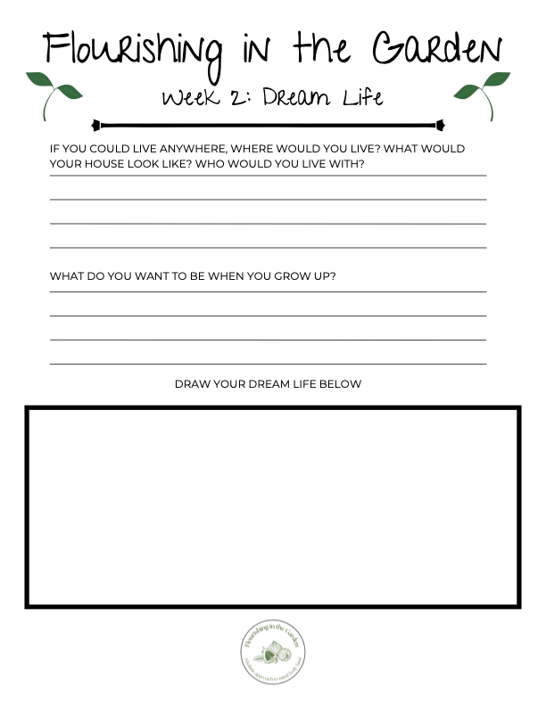
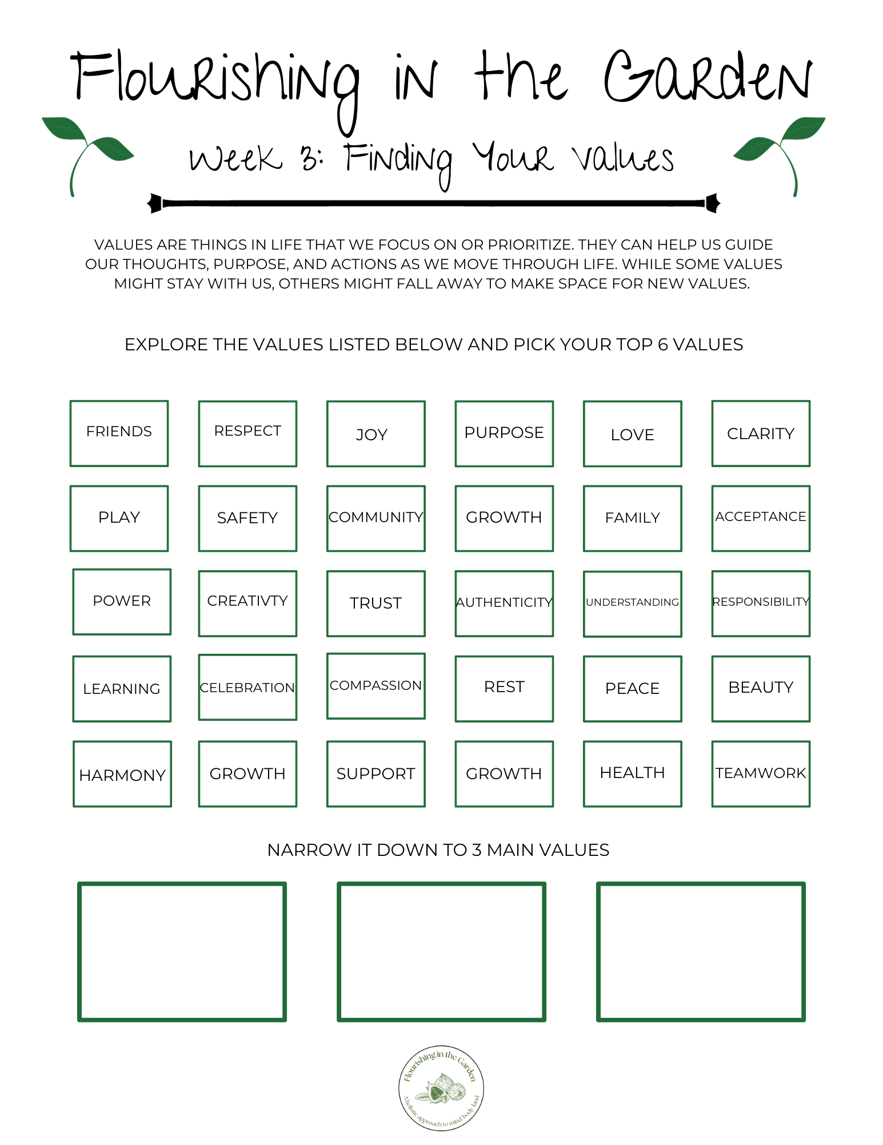
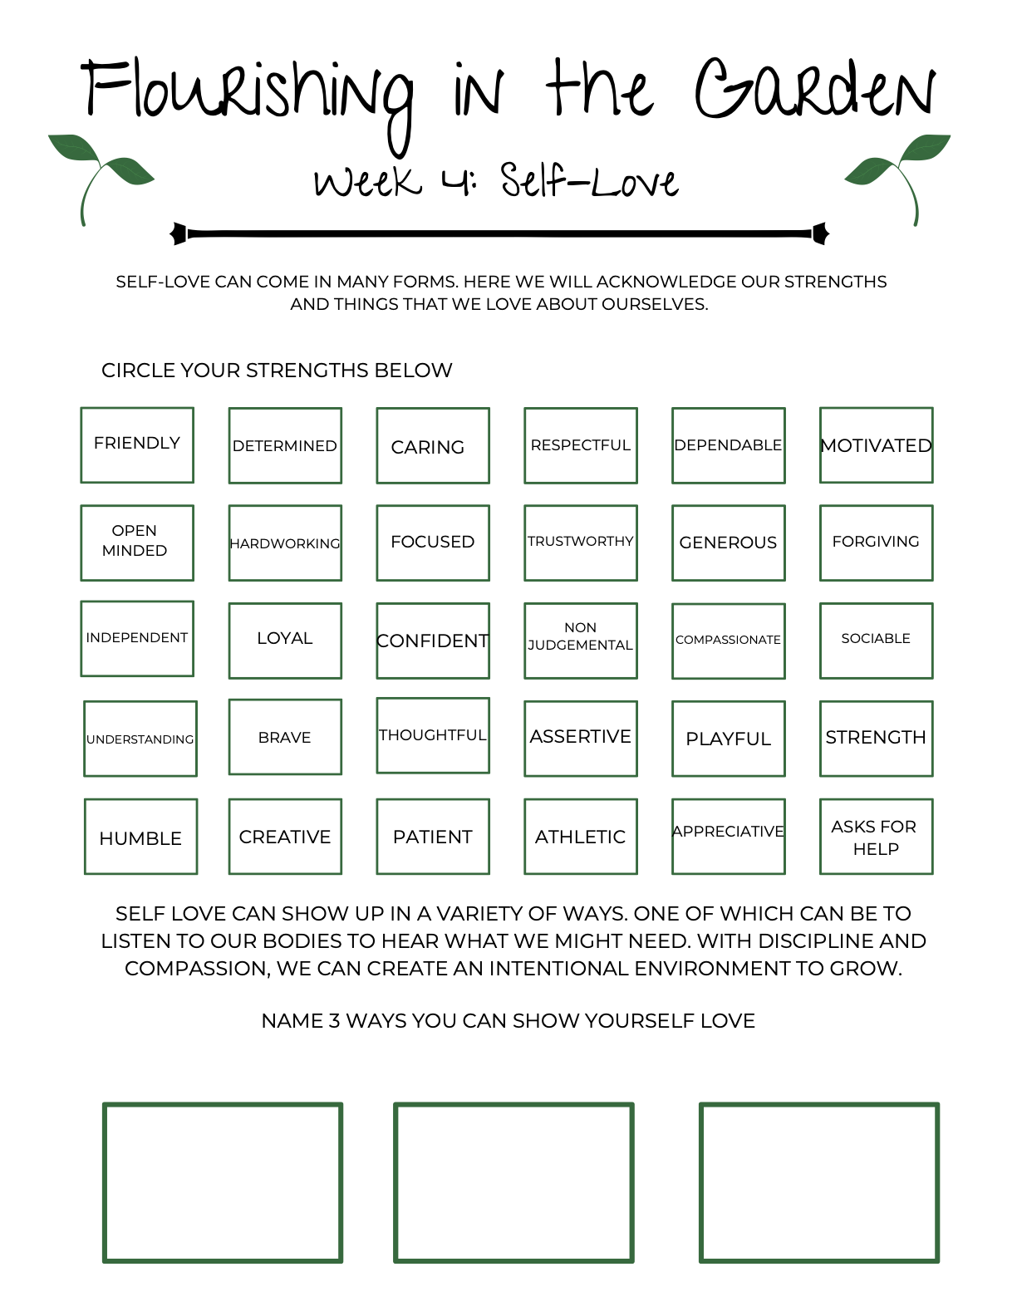

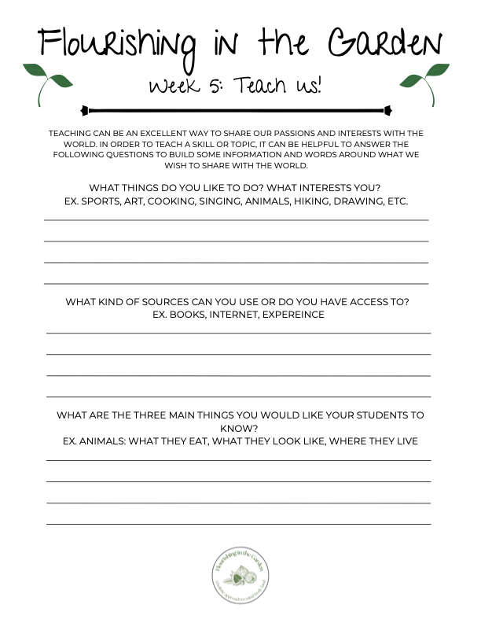

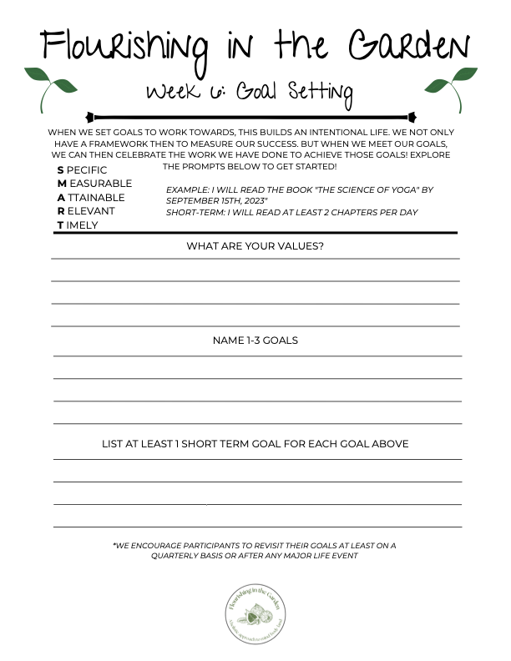
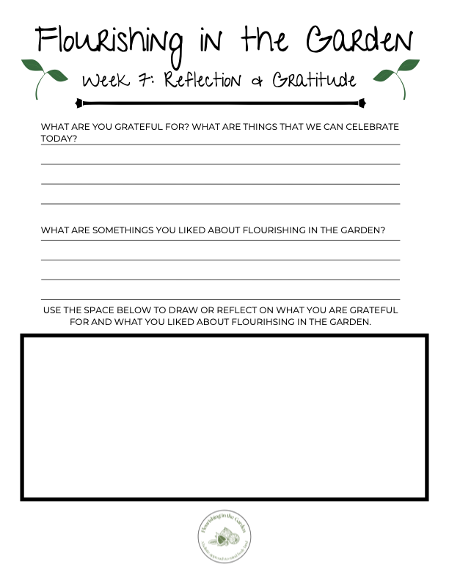

Activities
Fruit Basket Affirmations
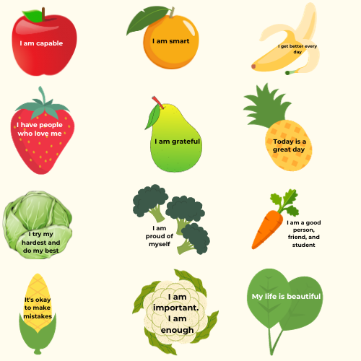
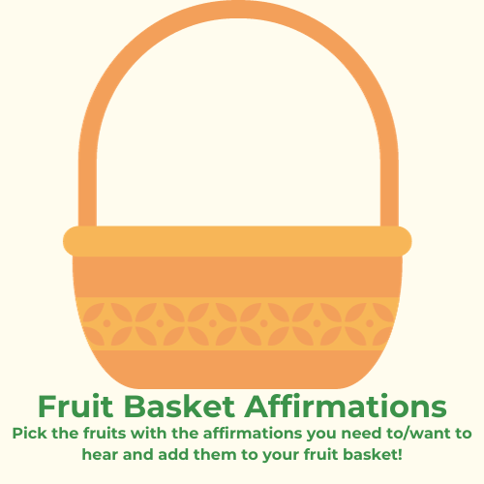

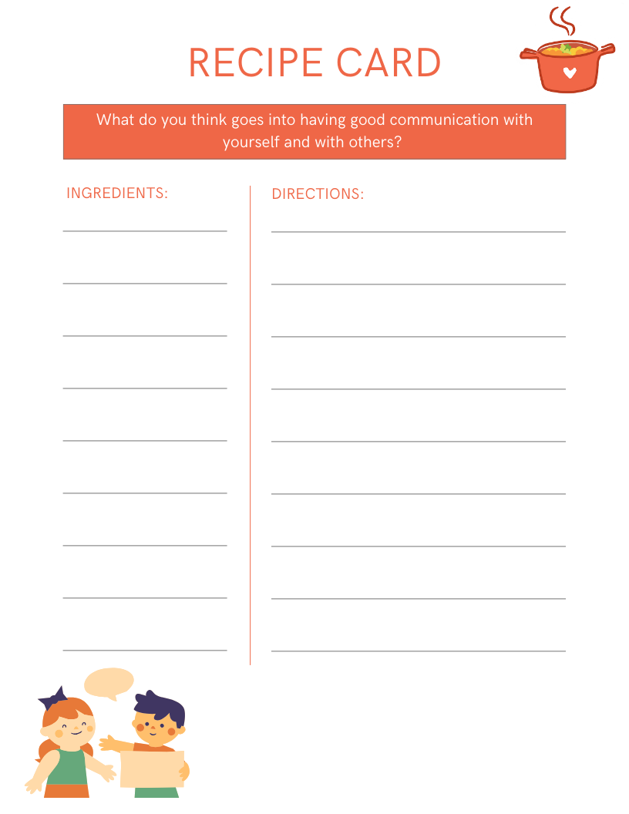
Good Communication Recipe Card

Values Assessment Definitions
FRIENDS | a favored companion
RESPECT | An act of giving particular attention; consideration (thoughtful regard, sympathetic regard, understanding the needs of others)
JOY | State of happiness
PURPOSE | Aim of oneself for an intent/goal, to set before the mind (an action, discussion, etc)
LOVE | Warm attachment, devotion or admiration
CLARITY | the state of having a full, detailed, and orderly mental grasp of something; the quality of being clear
PLAY | to deal in a light, speculative, or sportive manner
SAFETY | the condition of being safe from undergoing or causing hurt, injury, or loss
COMMUNITY | Unified body of individuals: such as  - the people with common interests living in a particular area  - persons or nations having a common history or common social, economic, and political interests
GROWTH | Development, maturing
FAMILY | the basic unit in society traditionally consisting of two parents rearing their children, those in which we have relations to
ACCEPTANCE | State of being accepted, approval, included
POWER | Influence over others; physical might; mental or moral efficacy; political control or influence
CREATIVITY | Quality of being creative (to produce through imaginative skill)
TRUST | Assured reliance on the character, ability, strength, or truth of someone or something; to place confidence in, or rely on the truthfulness of
AUTHENTICITY | True to one's own personality, spirit, or character
UNDERSTANDING | A mental grasp, Tolerance, Sympathy (the act or capacity of entering into or sharing the feelings or interests of another)
RESPONSIBILITY | Moral, legal, or mental accountability
LEARNING | to gain knowledge or understanding of or skill in by study, instruction, or experience
CELEBRATION | to observe a notable occasion with festivities
COMPASSION | Sympathetic consciousness of others' distress together with a desire to alleviate it
REST | Sleep, repose, peace of mind/spirit, freedom from activity or labor
PEACE | a state of tranquility or quiet; freedom from disquieting or oppressive thoughts or emotions
BEAUTY | a particularly graceful, ornamental, or excellent quality; qualities in a person or thing that gives pleasures to the senses (mind and spirit)
HARMONY | Pleasing arrangement of parts; tranquility
SUPPORT | Assist, help; to keep from fainting, yielding, or losing courage
HEALTH | The condition of being sound in body, mind, or spirit
TEAMWORK | Work done by a group acting together so that each member does a part that contributes to the efficiency of the whole
Source: mirriam-webster.com/dictionary
Pre/Post Assessments

